# **База данных**

## Задание 1

Число автомобилей:  
5500

Запрос, которым тебе удалось решить задачу.

chicago_taxi=# select count(distinct vehicle_id) from cabs;

count

-------

5500

(1 row)

## Задание 2

Список компаний с числом автомобилей меньше 100.

cnt | company_name

-----+----------------------------------------------

97 | Nova Taxi Affiliation Llc

89 | Patriot Taxi Dba Peace Taxi Associat

85 | Blue Diamond

81 | Checker Taxi Affiliation

80 | Chicago Medallion Management

69 | Chicago Independents

67 | 24 Seven Taxi

60 | Checker Taxi

55 | American United

53 | Chicago Medallion Leasing INC

49 | Top Cab Affiliation

48 | KOAM Taxi Association

38 | Chicago Taxicab

34 | Norshore Cab

20 | Gold Coast Taxi

20 | Metro Group

18 | Service Taxi Association

14 | 5 Star Taxi

8 | American United Taxi Affiliation

8 | Metro Jet Taxi A

7 | Setare Inc

5 | Leonard Cab Co

1 | 4615 - 83503 Tyrone Henderson

1 | 5062 - 34841 Sam Mestas

1 | 4623 - 27290 Jay Kim

1 | 5997 - 65283 AW Services Inc.

1 | 2092 - 61288 Sbeih company

1 | 1469 - 64126 Omar Jada

1 | 2733 - 74600 Benny Jona

1 | 2192 - 73487 Zeymane Corp

1 | 5006 - 39261 Salifu Bawa

1 | 3556 - 36214 RC Andrews Cab

1 | 3721 - Santamaria Express, Alvaro Santamaria

1 | 2809 - 95474 C & D Cab Co Inc.

1 | 2241 - 44667 - Felman Corp, Manuel Alonso

1 | 3620 - 52292 David K. Cab Corp.

1 | 2823 - 73307 Lee Express Inc

1 | 6057 - 24657 Richard Addo

1 | 6742 - 83735 Tasha ride inc

1 | 1085 - 72312 N and W Cab Co

1 | 3591 - 63480 Chuks Cab

1 | 0118 - 42111 Godfrey S.Awir

1 | 6574 - Babylon Express Inc.

1 | 3094 - 24059 G.L.B. Cab Co

1 | 5874 - 73628 Sergey Cab Corp.

1 | 6743 - 78771 Luhak Corp

1 | 5074 - 54002 Ahzmi Inc

1 | 3623 - 72222 Arrington Enterprises

1 | 4053 - 40193 Adwar H. Nikola

1 | Chicago Star Taxicab

1 | 3011 - 66308 JBL Cab Inc.

(51 rows)

Запрос, которым тебе удалось решить задачу.

chicago_taxi=# select count(vehicle_id) as cnt, company_name from cabs group by company_name having count(vehicle_id) < 100 order by cnt desc;

## 

## 

## 

## 

## 

## 

## Задание 3

Таблица с данными за указанный период.

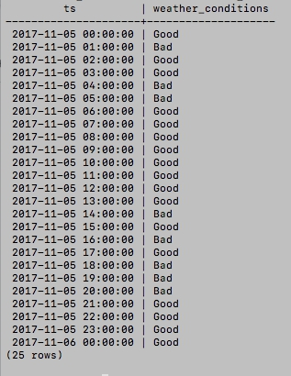

Запрос, которым удалось решить задачу.

chicago_taxi=# select ts, case when description like '%rain%' then 'Bad' when description like '%storm%' then 'Bad' else 'Good' end as weather_conditions from weather_records where ts between '2017-11-05 00:00' and '2017-11-06 00:00';

## 

## 

## 

## 

## 

## 

## Задание 4

Таблица с данными за указанный период.

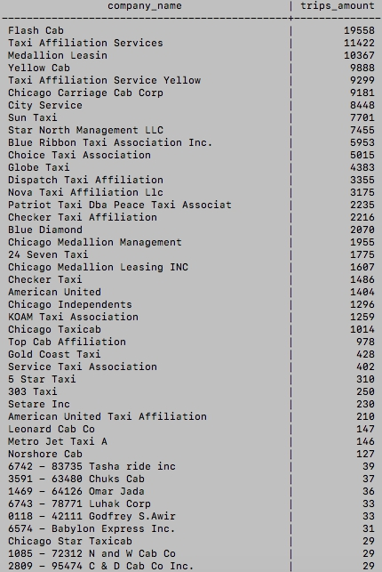

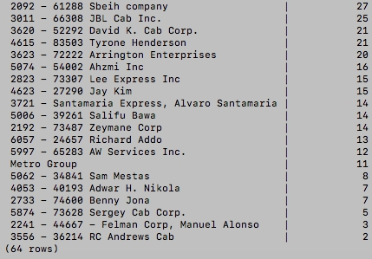

Запрос, которым удалось решить задачу.

select cabs.company_name,count(trips.trip_id) as trips_amount from cabs INNER JOIN trips ON cabs.cab_id=trips.cab_id where trips.start_ts >= '2017-11-15 00:00:00' and trips.start_ts <= '2017-11-16 23:59:59' group by company_name order by trips_amount desc;